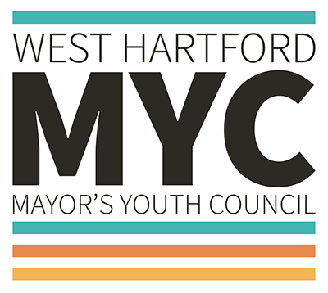
West Hartford Mayor’s Youth Council
APPLICATION 2021-2022

The West Hartford Mayor’s Youth Council is an advisory group of 9th-12th grade students who represent different schools, neighborhoods, backgrounds and interests. They meet from September – May to plan and complete impact projects and work with town departments and organizations to help with local initiatives throughout the year. Evening meetings are held on the third Tuesday of each month from 6-7 PM. Students who are interested in civic engagement, community service, and/or activism should complete an application to be considered for appointment. Additionally, a personal essay and letter of reference must be sent to Teen Services Librarian Kari Karp no later than May 31, 2021.
Mayor’s Youth Council members will be chosen over the summer by the West Hartford Libraries Teen Librarian, a staff member from the West Hartford Public Schools Administration, and/or a Town Council member based on submitted materials and an in-person or virtual interview.
Name: ________________________________________ Date of Birth: ______________________________
Address: ______________________________________ Phone: ____________________________________
Email: ________________________________________ School: ___________________________________
Graduating Year: _______________________________

Rules and Expectations for Mayor’s Youth Council (MYC) Members
Applicants/Members will:
- Complete application process includes 1) application, 2) essay, 3) 1 letter of reference from an adult 4) interview.
- Serve a term of one year and may re-apply to serve a second term.
- Participate and contribute at all meetings and spend approximately 2-3 hours per month completing projects, facilitating events, or working in sub-committees.
- Be allowed one excused absence.

Please answer the following questions:
1. What are your current or previous volunteer experiences?
Volunteer Activity | Approximate Hours Completed | Dates (To/From)
Ex. Mayor’s Youth Council | 27 | 2021-2022
2. What would make you a good MYC member? What interests or skills do you possess that will help the group complete community service projects that enhance the quality of life of youth in West Hartford?

3. Which officer position (e.g. chair, co-chair, secretary) are you interested in and what leadership skills make you an ideal candidate for that role?

4. Indicate your extracurricular commitments (sports, clubs, classes, etc.) that may or may not conflict with your participation with MYC activities.
Activity | M | T | W | T | F
Ex. Mayor’s Youth Council |  | 6-7PM
Parent / Guardian Information
I acknowledge that my child is applying for a position on the West Hartford Mayor’s Youth Council.

Parent/Guardian Signature: ___________________________________________ Date: ______________
Phone: _________________________ Email: ________________________________________________

Letter of Reference: Please list contact information for one adult (non-family) reference. This individual should e-mail a letter of reference to teenvolunteers@westhartfordlibrary.org by May 31, 2021.

Reference Name: ________________________________________________________________________
Relationship to Applicant: _________________________________________________________________
Phone: __________________________ Email: _________________________________________________

Personal Essay: Please complete this essay on a separate sheet of paper (200-500 words, double-spaced). Choose one of the topics below.

1. What do you think is the most challenging issue that youth currently face in West Hartford? Discuss in detail how you would recommend that the West Hartford Mayor and Town Council address this issue?

OR

2. What experience do you have working on a project to improve your community or speaking out on youth or community issues?

Applicants should send a signed and completed application and personal essay to Teen Services Librarian Kari Karp at teenvolunteers@westhartfordlibrary.org no later than May 31, 2021.

References should send their letter of recommendation separately to Teen Services Librarian Kari Karp at teenvolunteers@westhartfordlibrary.org no later than May 31, 2021.

Questions?
Please contact the West Hartford Libraries Teen Department at teenvolunteers@westhartfordlibrary.org.

